Sample Template, Bold, Cambria Font, Size 16, 1.5 Line Spacing
First Author¹, Second Author², Third Author³ (Font Size 12)
¹ First Author Affiliation & Address
² Second Author Affiliation & Address (Font size 11)
³ Example: Professor, Dept. of xyz Engineering, xyz college, state, country

Abstract: An abstract summarizes, in one paragraph (usually), the major aspects of the entire paper in the following prescribed sequence. The abstract of your paper must be 250 words or less. This electronic document is a “live” template. The various components of your paper [title, text, heads, etc.] are already defined on the style sheet, as illustrated by the portions given in this document. Do not use special characters, symbols, or math in your title or abstract. The authors must follow the instructions given in the document for the papers to be published. This template, modified in MS Word 2007 and saved as a “Word 97-2003 Document (Size 10 & Italic , Cambria font)
Key Words: (Size 10 & Bold) Key word1, Key word2, Key word3, etc (Minimum 5 to 8 key words)

Received Date: Revised Date: Acceptance Date:

- INTRODUCTION (Size 12, Cambria font)
This document is template. We ask that authors follow some simple guidelines. In essence, we ask you to make your paper look exactly like this document. The easiest way to do this is simply to download the template and replace(copy-paste) the content with your own material.
Number the reference items consecutively in square brackets (e.g. [1]). However the authors name can be used along with the reference number in the running text. The order of reference in the running text should match with the list of references at the end of the paper.
- Sub Heading 1 (Size 11, Cambria font)
Before you begin to format your paper, first write and save the content as a separate text file. Keep your text and graphic files separate until after the text has been formatted and styled. Do not use hard tabs, and limit use of hard returns to only one return at the end of a paragraph. Do not add any kind of pagination anywhere in the paper. Do not number text heads-the template will do that for you.
Finally, complete content and organizational editing before formatting. Please take note of the following items when proofreading spelling and grammar:
1.2 Sub Heading 2
Sample paragraph, The entire document should be in cambria font. Type 3 fonts must not be used. Other font types may be used if needed for special purposes. The entire document should be in cambria font. Type 3 fonts must not be used. Other font types may be used if needed for special purposes.
- HEADING 2
BMRJ Template sample paragraph. Define abbreviations and acronyms the first time they are used in the text, even after they have been defined in the abstract. Abbreviations such as IEEE, SI, MKS, CGS, sc, dc, and rms do not have to be defined. Do not use abbreviations in the title or heads unless they are unavoidable.
Table -1: Sample Table format
Preparation of Manuscript
Margins: Top | 1.5” | Bottom | 1.0”
Left | 1.5” | Right | 1.0”
Margin: | Custom | Font | Cambria / 10 pt
Title of paper: | 16 Point | Heading | 12 Point
Sub-Heading: | 11 Point | Spacing | Single line spacing

BMRJ template sample paragraph BMRJ template sample paragraph. BMRJ template sample paragraph BMRJ template sample paragraph BMRJ template sample paragraph BMRJ template sample paragraph. BMRJ template sample paragraph BMRJ template sample paragraph BMRJ template sample paragraph BMRJ template sample paragraph BMRJ template sample paragraph. BMRJ template sample paragraph BMRJ template sample paragraph BMRJ template sample paragraph BMRJ template sample paragraph BMRJ template sample paragraph.
BMRJ template sample paragraph, BMRJ template sample paragraph. BMRJ template sample paragraph. BMRJ template sample paragraph
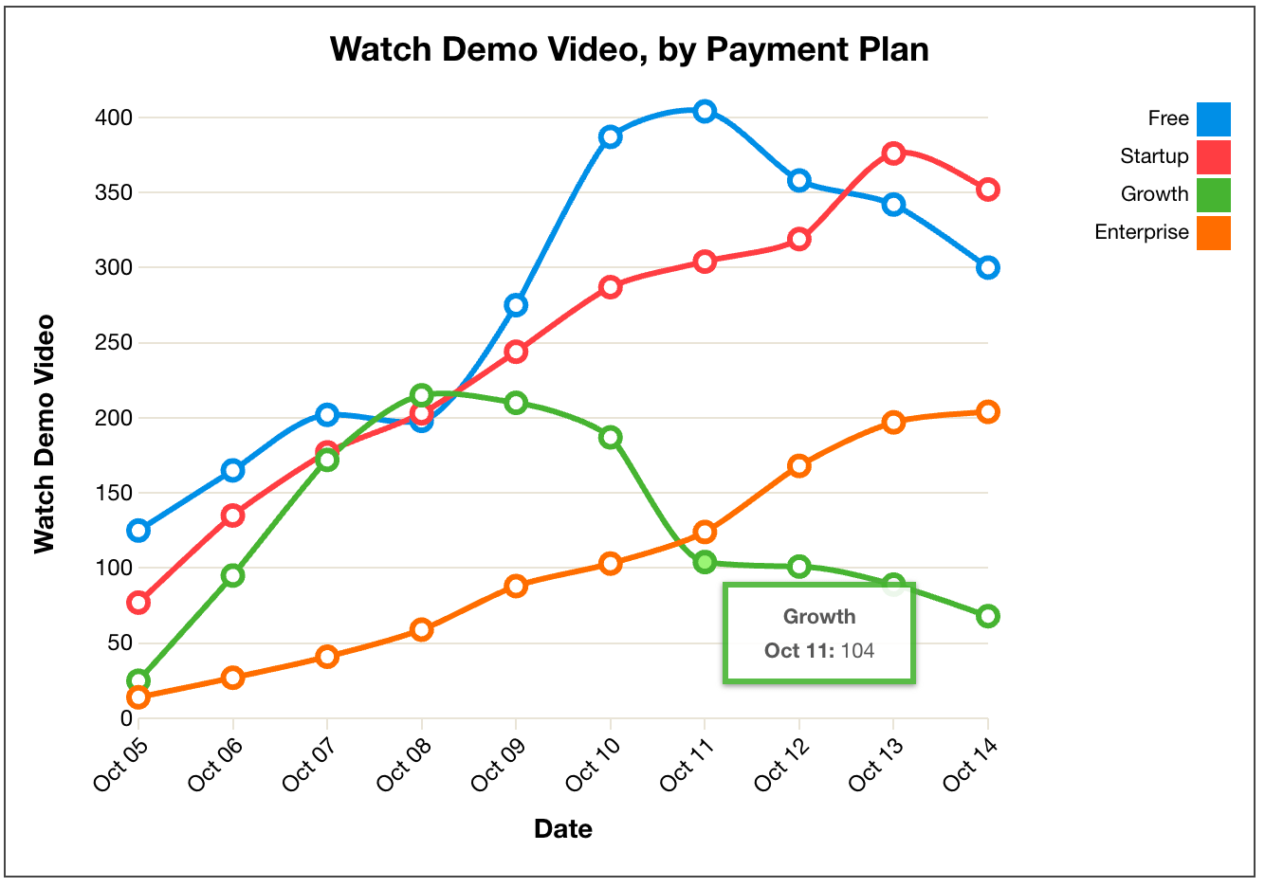
Chart -1: Name of the chart

BMRJ sample template format, define abbreviations and acronyms the first time they are used in the text, even after they have been defined in the abstract. Abbreviations such as IEEE, SI, MKS, CGS, sc, dc, and rms do not have to be defined. Do not use abbreviations in the title or heads unless they are unavoidable.

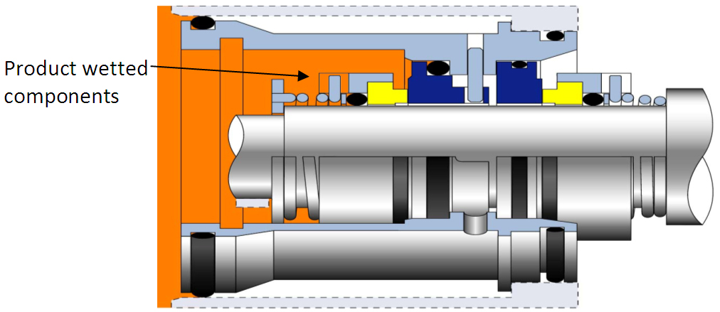
Fig -1: Name of the figure
Sample paragraph Define abbreviations and acronyms the first time they are used in the text, even after they have been defined in the abstract. Abbreviations such as IEEE, SI, MKS, CGS, sc, dc, and rms do not have to be defined. Do not use abbreviations in the title or heads unless they are unavoidable.
After the text edit has been completed, the paper is ready for the template. Duplicate the template file by using the Save As command and use the naming convention prescribed by your conference for the name of your paper. In this newly created file, highlight all of the contents and import your prepared text file. You are now ready to style your paper.
- RESULTS AND DISCUSSION
BMRJ sample template format, Result and discussion content comes here. Result and discussion content comes here Result and discussion content comes here Result and discussion content comes here Result and discussion content comes here Result and discussion content comes here Result and discussion content comes here Result and discussion content comes here Result and discussion content comes here Result and discussion content comes here Result and discussion content comes here Result and discussion content comes here Result and discussion content comes here . The results and discussion content comes here.
- CONCLUSIONS
BMRJ sample template format, Conclusion content comes here. Conclusion content comes here Conclusion content comes here Conclusion content comes here Conclusion content comes here Conclusion content comes here Conclusion content comes here Conclusion content comes here Conclusion content comes here Conclusion content comes here Conclusion content comes here Conclusion content comes here Conclusion content comes here . Conclusion content comes here.
ACKNOWLEDGEMENT (Optional)
The authors can acknowledge any person/authorities in this section. This is not mandatory.
REFERENCES
- Standard Journal Article
Shah DP, Jani GK, Modification and Characterization of Gellan Gum, Pharmaceutical Technology, 2009; 33(7): 48-58.
- Books and other Monographs
Author(s) of Book (Surname initials). Title of Book. Edition. Publisher; Place of publication; Year of publication.
- Personal author(s)
Eisen HN. Immunology: an introduction to molecular and cellular principles of the immune response. 5th Edition. New York: Harper and Row; 1974.
- Chapter or Article in a book
Kelly HW and Sorknes CA. Asthma, Dipiro JT, Talbert RL, Yee GC, Matzke TR, Wells BG, Posey LM, Pharmacotherapy- A Pathophysiological Aproch, Sixth Edition, The McGraw-Hill; 2005.504
- Patent
Larsen CE, Trip R, Johnson CR, inventors; Novoste Corporation, assignee. Methods for procedures related to the electrophysiology of the heart. US patent 5529 067. 1995.

BIOGRAPHIES (Optional not mandatory)
1’st Author  Photo | Description about the author1  (in 4-6 lines)
2nd Author Photo | Description about the author2  (in 4-6 lines)

